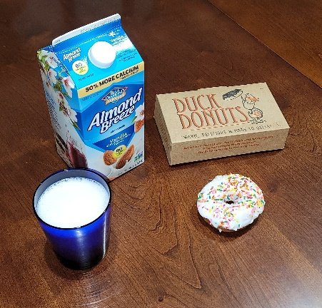 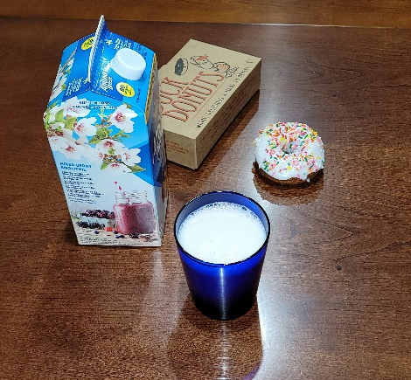 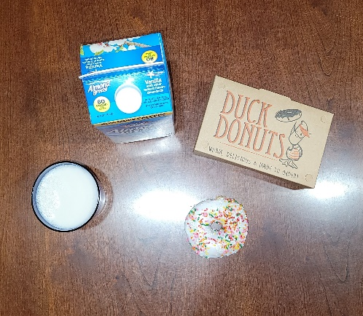

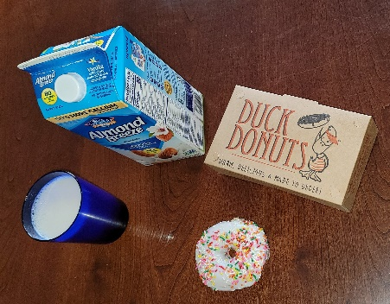 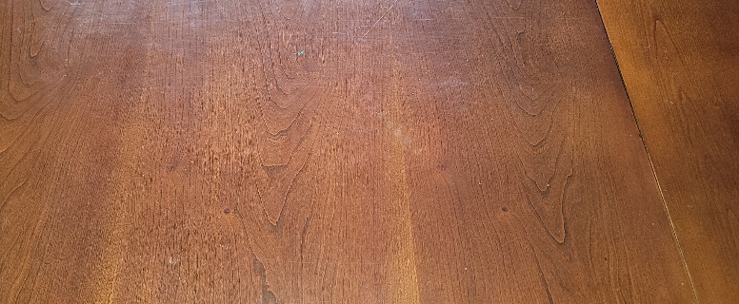

The items in my images that I propose to create in 3D are the doughnut, the doughnut box, the drink glass, and the almond milk carton. The plane that will be used is the table that the items are situated on. I think these are items are good choices for my work because they can all be made with a variety of simple primitive shapes, I have pictures of the objects at multiple angles, including some not disclosed on this assignment, and because I think it is a fun setting for this learning objective.

With the table as the plane, I plan on using a torus to create a 3D representation of the doughnut item. This makes sense because the shapes are identical. The doughnut box can be created with a cube since the interior angles of the box are all right angles and there are six faces with one facing the plane. The blue drinking glass can be created using a cylinder because of the parallel two circular bases and curved surface. The almond milk in the glass can created using a texture of the top of the picture. The fourth object, the almond milk carton, can be created using multiple primitive shapes. A cube can be used to create the base of the carton. The top of the carton is in the shape of a prism. The prism can be broken down into multiple component shapes. The base of the prism is rectangular and can be created using a cube. The sides of the prism are triangular and can be created using a pyramid. The blue cap on one of the faces of the cube can be represented using a cylinder. These choices will allow me to gain experience using a good assortment of the listed options for shapes for this project making for a comprehensive and exciting experience.